Microservices with API gateway

Exercise: Creating Microservices for account and loan
Description: Created two separate Spring Boot microservices (account and loan) using Spring Initializr with the Spring Web and DevTools dependencies. Built simple REST controllers to return dummy JSON data for accounts and loans based on URL path variables.
Source Code:
Account Microservice: src/main/java/com/cognizant/account/AccountController.java
Java
package com.cognizant.account;

import org.springframework.web.bind.annotation.GetMapping;
import org.springframework.web.bind.annotation.PathVariable;
import org.springframework.web.bind.annotation.RestController;
import java.util.HashMap;
import java.util.Map;

@RestController
public class AccountController {
@GetMapping("/accounts/{number}")
public Map<String, Object> getAccountDetails(@PathVariable String number) {
Map<String, Object> response = new HashMap<>();
response.put("number", number);
response.put("type", "savings");
response.put("balance", 234343);
return response;
}
}
Loan Microservice: src/main/java/com/cognizant/loan/LoanController.java
Java
package com.cognizant.loan;

import org.springframework.web.bind.annotation.GetMapping;
import org.springframework.web.bind.annotation.PathVariable;
import org.springframework.web.bind.annotation.RestController;
import java.util.HashMap;
import java.util.Map;

@RestController
public class LoanController {
@GetMapping("/loans/{number}")
public Map<String, Object> getLoanDetails(@PathVariable String number) {
Map<String, Object> response = new HashMap<>();
response.put("number", "H00987987972342");
response.put("type", "car");
response.put("loan", 400000);
response.put("emi", 3258);
response.put("tenure", 84);
return response;
}
}
Outputs / Screenshots:
- Account Service:
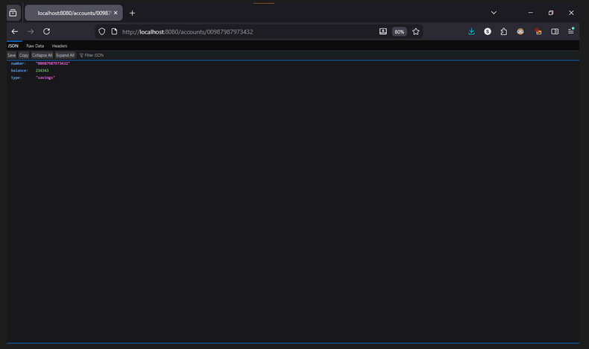
- Loan Service: 